**Chinatown Pharmacy Naturopath’s Newsletter Feb 2015**

***February is Febfast month!***

You’ve survived Christmas, office parties, New Year and Australia Day celebrations but are you feeling the after effects?

It’s a time of over indulgence and good times but these do take a toll on your body, health, waistline and wallet. So how about taking a break? Febfast is a great way to get back on track. What is it? Febfast is a charity that raises money to fight youth addiction but it also helps you to take that initial step to a healthier new year. Double benefit! In the past Febfast has focused on giving up alcohol for a month but in 2015 there are 5 vices you can choose from! Alcohol, sugar, social media, smoking and junk food.

Get together with friends for a group challenge, organise your workplace to participate or just go solo.

**It works!**

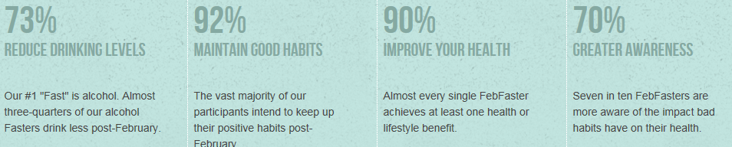

Source: <http://febfast.org.au/about/> Read more on this link and get involved.

**So which organ bears the brunt of our overindulgence?**

**Answer: the liver!**

**Your liver-** *why you need to love it and how febfast can help !*

Your liver is vital for good health. It works tirelessly to deal with everything you eat, drink and breathe. It has many functions yet is often neglected or overlooked. It produces bile that breaks down fats and removes wastes, sorts and uses protein components for use by the

body, helps stabilise blood sugars, packages and removes wastes produced by the body and neutralises and eliminates toxins we accumulate from food, chemicals, alcohol etc.

Poor dietary choices, drugs, chemical exposure and excess alcohol can lead to a sick or sluggish liver.

Some symptoms you may experience:

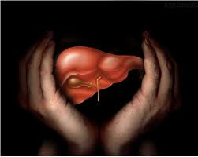

* Digestive discomfort
* Bloating, nausea
* Intolerance to fatty foods
* Headaches and migraines
* Recurrent infections
* Fatigue
* Muscle weakness and pain
* Hormone imbalances
* Emotional disturbance – anger, irritability (*older folk would call you “liverish”, get the connection?*)

**Loving your liver!**

Detoxification can help your liver and you can talk to our naturopath for a full detox programme, but here are some basic diet and lifestyle practices that you can employ to create a happy love affair with your liver.

* Avoid deep fried foods and fatty foods
* Avoid or reduce alcohol consumption
* Avoid refined sugars and junk food
* Eat fresh unprocessed food with a focus on vegetables and some fruit. (organic if possible please!).
* Eat good protein each day to assist the liver produce nutrients used in detoxifying processes
* Reduce exposure to chemicals and check household products – go green!
* Avoid exposure to xenoestrogens in plastics, cosmetics and many toiletries and household products. These cause hormonal disturbances as they act on oestrogen receptors in the body.
* Drink at least 2 litres of water per day to assist flushing of toxins

**Tip! Start the day with a large glass of water and the juice of half a fresh lemon to kick start your system!**

We recommend you see our Naturopath if you experience some of the above symptoms. We have many products especially designed to support the liver and get it back into great shape. It is an organ that can regenerate. Many health ailments such as high cholesterol, hormonal problems, PMS, emotional problems etc, can be helped by improving liver function.

**Some of the herbs your liver loves!**

***St. Mary’s Thistle***

This herb is a fabulous liver protector and antioxidant. It also protects cell membranes and has anti-inflammatory properties.

**Gl*obe Artichoke***

This herb is a liver protective and restorative and also is a great herb for the gall bladder. It aids bile formation and flow to help with fat digestion. Available from our dispensary as a liquid extract.

***Dandelion***

An old favourite for liver and gall bladder health. A personal favourite is Dandelion coffee substitute which I brew or filter and then add frothed milk for a cappuccino substitute! Tastes yummy!

Also available as a dispensed liquid extract and included in liver formulas available at the pharmacy.

***Bupleurum***

This herb works on the liver and gall bladder meridians and is a prime herb for liver detoxification. It also relieves tension and spasms, balances emotions (especially with PMS) and helps discharge toxins from the body. It also has cardiovascular and immune system benefits.

***Rosemary***

Rosemary increases the flow of bile to assist in the digestion of fats but it also acts as a great antioxidant, minimizing the harm caused by free radicals in the body.

***Turmeric***

Turmeric is the subject of much clinical research and it has many health benefits. It helps protect the liver and stimulate bile secretion but is also known as an anticancer agent, anti-inflammatory and an excellent player assisting irritable bowel syndrome.

***Schisandra***

Up to 30 different lignans have been identified in this herb that contribute to its liver protective action.As added benefits it is an adaptogen so helps the body to adapt to stress and helps improve concentration and reduce irritability. As a kidney tonic it also helps eliminate wastes, an essential part of detoxification.

At Chinatown Pharmacy we can formulate an individualized herbal formula to support your liver and gall bladder and to aid detoxification. We also have several practitioner quality products in tablet form if you prefer, to aid liver health and assist in detoxifying after those periods of over indulgence.

**Wanting to quit smoking for Febfast?**

Our pharmacies stock several products to help you give up this habit. We also provide professional advice to help you select the best option available that will enable you to stick with your resolution. We know giving up is hard but it is worth it for your health and the right advice can make all the difference. Speak to our trained staff and use Febfast as your personal motivation to get started. Get some friends and family to sponsor you and know that you are helping kids avoid the trap of addiction through your fund raising efforts.

You can do it!

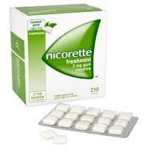

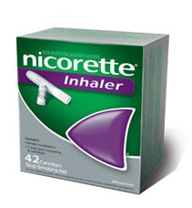

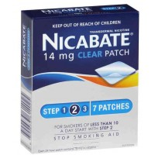

**Juicing for health**

Juices not only provide nutrients needed for effective liver detoxifying processes but they also aid the elimination of wastes and toxins produced when we stimulate the liver pathways. There are many ingredients that not only help these processes but also boost the immune system and support the body in dealing with infections, colds etc.

Common ingredients in detox juices include apples, carrots, beetroot, lemons, ginger and green leafy vegetables. Some ingredients are best juiced in juice appliances but high speed blenders also can be used but may not extract all the juice or provide the same level of textural smoothness.

A good juicer is an excellent investment!

Some useful recipe sites are:

<https://juicerecipes.com/recipes/>

An informative site!

<http://www.health.com/health/gallery/0,,20559953_8,00.html>

**A-Z of Vitamins**

**Vitamin A**

Vitamin A is a fat soluble vitamin and as such can be stored in the liver.

What it does:

* Maintains healthy skin and mucous membranes- so helps protect against infection of the lungs, nose, throat, digestive tract and urinary tract.
* Helps form pigments necessary for effective night vision
* Needed for healthy foetal growth
* Influences bone development
* Helps support immunity
* Is a major antioxidant
* Aids the reproductive system and fertility

Food sources

Liver, kidney, butter, milk, cod liver oil are pure Vitamin A foods.

Carotenes are a favoured source of Vitamin A as they have pro Vitamin A activity and they don’t have the toxicity concern that excess doses of Vitamin A can have. Carotenes are found in dark green leafy vegetables and yellow orange vegetables and fruits, legumes, grains, seeds, salmon, egg yolks, fish, milk, poultry and is being sourced in supplement form from red algae.

Deficiency signs: frequent respiratory infections, goose bumps on the back of the upper arm, night blindness, skin disease, frequent infections of the mucous membrane areas..

Vitamin A supplements should be avoided in pregnancy due to danger of birth defects. Speak to your doctor before supplementing!

High doses as well as liver disease may lead to toxicity. Carotenes are safe.

Recipe File

Simple Artichoke Salad

One jar artichokes (drained)

Juice of a lemon

Chopped parsley

Black pepper

Toss artichokes and lemon juice. Sprinkle with parsley and black pepper.

*Artichokes contain silymarin, an antioxidant and liver support constituent. They are a great source of fibre to help sweep cholesterol and toxins from the bowel. One artichoke contains 20% of your daily fibre allowance.*

*One artichoke also provides 18% of your daily magnesium and 15% of your folate requirements. Add vitamin C (lemon juice), another powerful antioxidant and you have one very healthy salad your liver will love!*

